

Healthy Eating Policy

Cushinstown National School

Roll No. 16673R

As part of the Social, Personal and Health Education (SPHE) Programme at Cushinstown NS, we encourage the children to become more aware of the need for healthy food in their lunch boxes. What people eat is known to be a key factor that influences health. Research indicates a strong link between diet and performance e.g. a low sugar intake promotes concentration, lessens hyperactivity, protects teeth, and lessens the risk of diabetes. A low salt intake reduces the risk of heart disease in later life.

**Aims**

1. To promote the personal development and well-being of the child

2. To promote the health of the child and provide a foundation for all aspects of healthy living

**Objectives**

1. To enable the child to appreciate the importance of good nutrition for growing and developing and staying healthy.

2. To enable the child to accept some personal responsibility for making wise food choices and adopting a healthy, balanced diet.

Lunch is an important meal for school-going children. It should provide one third of their recommended daily allowance of nutrients without being high in fat, sugar or salt. It should also provide dietary fibre.

**The Food Pyramid**

A very simple approach to healthy eating is to use the Food Pyramid:

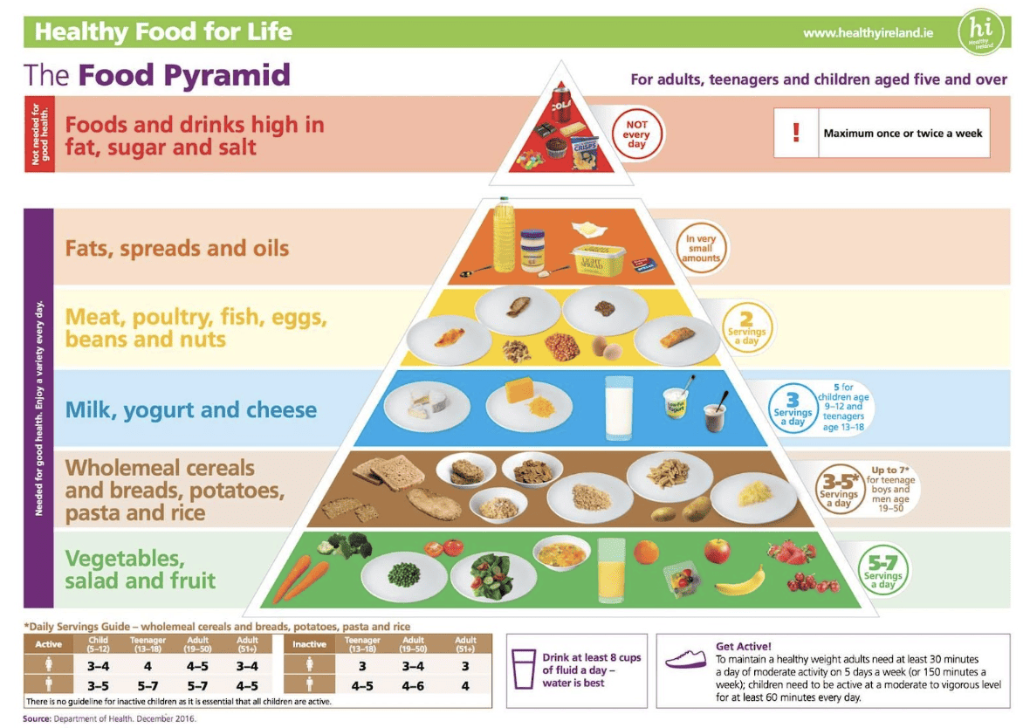

**Hot Lunches**

The Hot School Meals operates in schools and aims to provide regular, nutritious food to children. Since April 2023, hot lunches have been provided to the pupils in Cushinstown N.S. There are standards that the meals must meet.

These standards recommend that using the Food Pyramid as a guide, every hot lunch should contain:

* 2 servings of vegetables, salad or fruit
* 1 serving of wholemeal cereals and breads, potatoes, pasta and rice
* 1 serving of meat, poultry, fish, eggs, beans, cheese or nuts

Menus are updated on a regular basis and parents can login on the app to change their child’s hot lunch order.

Glanmore Foods is the company that provides hot lunches to the pupils at our school.

**Snacks**

Pupils also bring a snack to school. Parents and pupils are encouraged to use the Food Pyramid to help select a healthy choice for their snack.

We ask that pupils do not bring the following to school:

* Nuts - due to severe allergies in our school
* Crisps (including crisp-style snacks)
* Fizzy drinks (including fizzy fruit-flavoured water, juices, etc)
* Chocolate milk or drinks
* Sweets
* Chocolate spreads
* Chocolate biscuits/bars
* Buns and cakes
* Cereal bars
* Custard
* Fruit winders
* Lollipops
* Chewing gum

**Treats**

Friday is our treat day. Pupils are permitted to bring one small treat with their healthy snack.

**Special Occasions**

Exceptions can be made for special occasions e.g. end of term parties, class rewards and school trips.

**Pupil Input**

The Student Council was consulted on our Healthy Eating Policy on the 19/06/2025. They discussed hot food lunches, snacks, unhealthy foods and treats.They gave positive feedback about the hot lunches and reported that pupils enjoy them. Student Council representatives reported that snacks could be improved. Treats should be for Fridays only.

**Green Schools**

Our school is a green school and aims to be as environmentally friendly as possible. With this in mind, children are also asked to:

* take home all uneaten food, wrappers, containers and cartons
* use re-useable containers and recyclable materials
* not bring in cans and glass – for safety reasons.

**Medical conditions and special dietary requirements**

Parents/guardians of any child with a medical condition which requires a special diet should contact the school. The school should also be notified about any food allergies your child may have. For this reason we ask that parents and staff remind children not to swap or share food.

**Ratification & Communication**

This policy was ratified by the Board of Management of Cushinstown N.S.

Signed by Principal: ______________________ Date: __________________

Signed by Chairperson: ______________________ Date: __________________