

CUSHINSTOWN
NATIONAL SCHOOL

Cushinstown NS
Policy on Class Allocation.

School Mission Statement: Here in Cushinstown National School we provide an inclusive, happy learning environment where each child is given the opportunity to reach their full potential, where positive attitudes, mutual respect and teamwork is promoted.

1.Introduction

In the interest of providing the best education for all students in the school, it may from time to time be necessary to divide or combine a class grade into mixed classes. There are a number of reasons this may be necessary;

Teacher allocation to the school based on pupil numbers.

Offer better pupil-teacher ratio.

Possible examples;

First Class Grade split between Senior Infants and Second Class grades.

Combining 3rd and 4th class together.

The policy has been drawn up to provide a framework for such an event.
When splitting or combining class grades, parents should be assured that the children will follow the same curriculum, use the same learning materials and have the same learning opportunities. Children from the split class will also play together in the yard.
Time will be made available to the two teachers of the same grade to plan co-operatively in the three core subject areas (English, Irish & Maths). If staffing allows the split class will be together for a curricular area during the school week.

2. Framework for the splitting of classes

At the time of planning the classes for the coming year, the Principal will look at the following;
- Overall numbers in each year group and the number of teachers available to teach them.
- S/he will decide how best to organise classes with a view to providing the best educational opportunities and pupil-teacher ratio for all children in the school.

3. Criteria for placing children in particular groups

When dividing a class grade into separate groups, to be placed in separate classes, certain criteria will be taken into consideration:

- Teacher(s) input.
- Pupil input.
- Maintaining mixed-ability groups.
- Special educational needs.
- Class dynamics: emotional, behavioural, social and gender.
- Classroom accommodation.
- The process of forming new friendships is a key life skill which is important to develop. A positive attitude from parents is a key element in achieving a successful outcome in the new groups.

4. The allocation of teachers to mixed classes

It is the duty of the Principal as per Circular 16/73 to assign teaching duties. The Principal’s decision on the matter of class allocation is final; Requests for children to swap classes will not be permitted.

Signed: 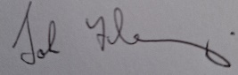 Signed: 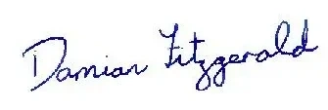
Chairperson, Board of Management Principal/ Secretary, Board of Management
Date: 17/06/2024 Date: 17/06/2024

